Atitit java code parse graph meth by pmd

**public** **static** String getValWarpFmt(String cType, Object object) {

**if** (cType.equals("BIGINT")) {

**return** object.toString();

}

**if** (cType.equals("TINYINT") || cType.equals("INT"))

**return** object.toString();

**if** (cType.equals("VARCHAR"))

**return** "'" + object.toString() + "'";

**if** (cType.equals("DATETIME")) {

**if** (object **instanceof** Map)

**return** ((Map) object).get("exp").toString();

**else**

**return** "'" + object.toString() + "'";

}

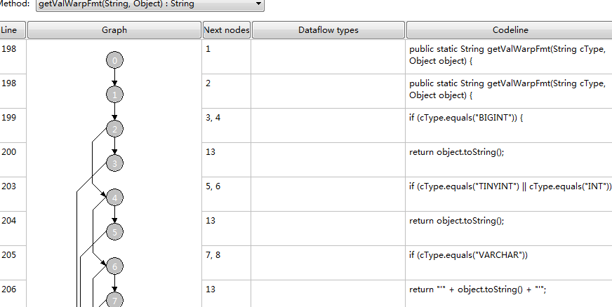

## Ast tool xpath designer

